**ROTARY YOUTH EXCHANGE AUSTRALIA**



**2022 ANNUAL CONFERENCE**

***Venue*: *Conference Dates*:**

**HOTEL GRAND CHANCELLOR Friday 21st October Informal Dinner**

**23 Leichhardt St Saturday 22nd October**

**Brisbane City. Sunday 23rd October Lunchtime Finish**

**QUEENSLAND AUSTRALIA.**

***Registration Form:* Please complete form and email to Bev Bartlett:** [**ryeaconference@gmail.com**](mailto:ryeaconference@gmail.com)

|  |  |  |
| --- | --- | --- |
| ***Name:*** |  | |
| ***District:*** |  | ***District Role:*** |
| ***Accompanied by:*** |  | |
| ***Address:*** |  | |
| ***Suburb:*** |  | ***Postcode:*** |
| ***Mobile phone:*** |  | |
| ***Email address:*** |  | |
| ***Flight Arrival date:*** |  | |
| ***Flight No:*** |  | |
| ***ETA flight arrival time:*** |  | |
| ***Special Dietary requirements:*** |  | |

**Type of Package required**

**Full Delegate Package includes the following:**

**Saturday lunch and Dinner for all delegates. Sunday lunch for all delegates.   
All morning/afternoon teas. (Excludes accommodation – see below)**

|  |  |
| --- | --- |
| ***Delegate*** | ***AUD$ 450 per person*** |
| ***Delegate and Partner*** | ***AUD$ 900*** |
| ***Extra Person at Chairs Breakfast*** | ***AUD$ 30 (only available to approved attendees)*** |
| ***Saturday night Gala dinner only*** | ***AUD$ 60.00 for 2 courses Drinks at Bar Price*** |

**ACCOMMODATION:  
Please book your accommodation directly with Hotel Grand Chancellor**



<https://www.grandchancellorhotels.com/hotel-grand-chancellor-brisbane>

**Mention that you are attending the RYEA Conference to receive group room rate**

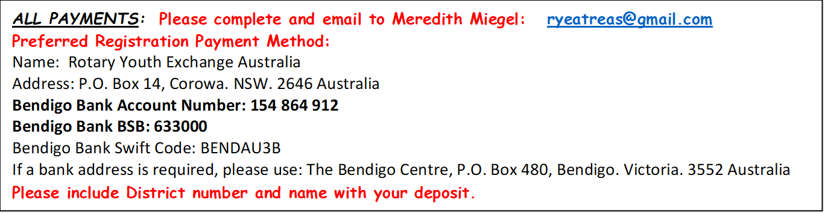

**Please register and pay before 1 August 2022**